Shabbos Stories for
Parshas terumah 5784
Volume 15, Issue 24 8 Adar Rishon 5784/February 17, 2024
Printed L’illuy nishmas Nechama bas R’ Noach, a”h
For a free subscription, please forward your request to keren18@juno.com
Past emails can be found on the website – ShabbosStories.com

Miracle in the Shomrei Shabbos Shul in Boro Park
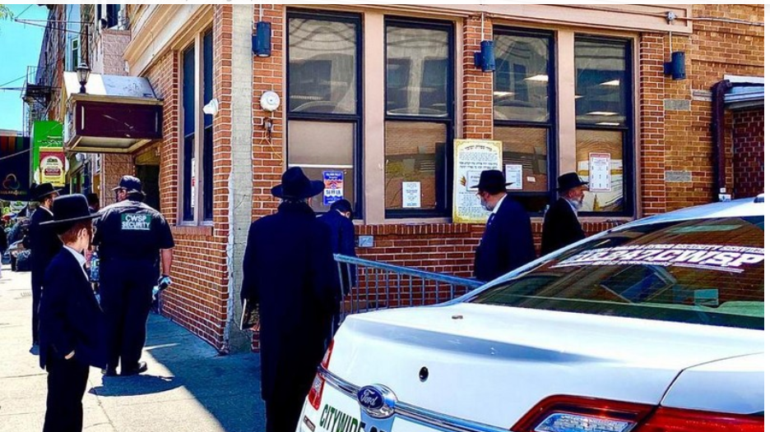
The outside of the iconic Boro Park – Shomrei Shabbos shul.
Rav Yitzchok Zilberstein related a story that a man from Boro Park shared with him. The man said: One night, I went to daven Maariv at the Shomrei Shabbos Shul in Boro Park, when a man approached me and introduced himself as a visitor from Eretz Yisroel. He showed me a check that had been made out for a very large sum, and he asked if I knew the person who had written the check.
I told him that I knew the man. He is a wealthy individual who lives near the Shul, but I also knew that he was not in the habit of giving out such large donations. I asked him , “How did you get that check?”

A Most Incredible Story
The man told me a story that was completely incredible. He said, “I live in Eretz Yisroel and I have fallen into terrible debt. After being pursued continually by my creditors, I realized that I had no choice but to come to America to collect money, simply so that I could have a way to feed my family and to pay off my debts.
“I have been here for two weeks already, and I barely managed to cover the cost of my airfare. Today was a particularly hard day, and I didn’t manage to collect even one penny. At the end of the day, I felt that I had reached the edge of despair, and I began to lose hope. However, I knew that I couldn’t go home without having collected a decent amount. On the other hand, I couldn’t simply stay here forever.
“My family is waiting for me in Eretz Yisroel. For a while, I walked around in a state of depression, and I couldn’t imagine how I would be able to help myself and my situation. Suddenly, a thought came to me. ‘Am I alone in the world? I know that I have a great Father in Shamayim, and He can do anything!’
“I decided that I would simply pour out my heart before Hashem. I came to this Shul and I began to prepare for Maariv. When I began davening, I felt a sense of elevation, the sort of feeling I experience only during Maariv on Yom Kippur. When I was in the middle of the brachos of Krias Shema, someone tapped me on the shoulder. I didn’t even look around to see who it was. I was completely immersed in my davening.

A Most Enthusiastic Davening
“I davened Shemoneh Esrei with more feeling and enthusiasm than I have ever felt before. I cried to Hashem that only He can save me, and that there is no true power in the world other than Him. When I finished davening, I felt as if a great weight had been lifted from my heart. The next thing I did was to rub my eyes in astonishment. Right next to my Siddur was this check, which was made out for the exact amount of money that I had hoped to collect throughout my stay in America!”
“I said to him, “I know the man who wrote that check very well, but this is totally uncharacteristic for him. He is generous and he gives a lot of Tzedakah, but he would never normally do something like this.”
I decided to make my way to this donor’s house and to find out the real story. I mentioned about the visitor from Eretz Yisroel, and asked if he knew the man, and he replied that he didn’t. I told him, “I saw this man with a check from you that was made out for a very large amount of money, and I wanted to find out if you really wrote that check.”
When the man heard my question, he paled and his hands began to tremble. I asked him what had happened? In response, he told me this story. “I went to daven Maariv in Shomrei Shabbos and I saw a man standing off to the side and davening. It immediately occurred to me that he must be a visitor from Eretz Yisroel who had come to raise money.

Felt Compassion for the Man He
Thought was from Eretz Yisroel
“I presumed that he had probably left a family with children behind in Eretz Yisroel, and I imagined that he longed to be with his family, but his financial situation left him no choice but to remain here. It also seemed, based on his appearance, that he couldn’t have been very successful in collecting more than a small sum. I assumed that he was probably disappointed and dejected over not being able to raise more money, and I imagined his wife’s reaction when he returned home with only a small amount.
“I found myself overflowing with compassion for this person, and I tapped him on the shoulder and asked if he had come from Eretz Yisroel, but he didn’t answer me. I decided to write a check and leave it on the table in front of him, and I left. After I wrote the check,” he continued, “I started thinking about what I had done, and I began wondering if I had made a mistake. Maybe this man wasn’t from Eretz Yisroel? Why did I assume that he was poor? What if he didn’t even have a family? I began having some feelings of regret for what I did, and I went somewhere else to daven Maariv. Even now, I am surprised at myself when I think about it.”

Making the Wealthy Man Feel Very Happy
I quickly corrected his bad feelings and reassured him, and I said, “Don’t worry, the situation is exactly as you thought it was before you wrote that check. This is just like the story in the Gemara of the man who gave his friend the benefit of the doubt, and it turned out to be correct in every detail. The man you saw in Shul is indeed a Talmid Chacham who has many debts to many creditors, but he was very ineffective in raising money. It’s true that he was feeling broken, and your check came at precisely the right time. That check saved him, and as soon as he received it, he began preparing to return to his family in Eretz Yisroel.”
This made the wealthy man very happy, and he acknowledged that it could only be Hashem who had guided the events in this, and in every situation!

Reprinted from the Parshas Bo 5784 email of Rabbi Yehuda Winzelberg’s Torah U’Tefilah.

Rav Moshe and
the Spilled Ink

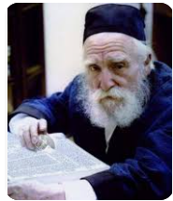

Once, Rav Moshe Feinstein, zt”l, received a very special and expensive new Shas, and was learning from the Mesechta Bava Metzia volume for the first time. Printed Seforim in those days were quite expensive and this new Gemara was a treasure.
Talmidim would pass by just to see it. It happened that Rav Moshe got up to get a different Sefer and Rav Nissan Alpert, zt”l, went over to his Rebbe’s Shtender to look at the new Gemara. By accident, he got a little too close and knocked into the inkwell, and spilled ink all over the brand new Gemara, staining the pages!
Just then, Rav Moshe came back and saw the ruined pages and the embarrassed Talmid. With a gentle smile, Rav Moshe said, “Doesn’t the Gemara look beautiful in blue?” referring to the blue ink that was now all over the pages of the Gemara.
Rav Alpert breathed a sigh of relief that his Rebbe didn’t seem to mind his mistake. He asked Rav Moshe, “How is it that the Rosh Yeshivah is not bothered at all by this? This expensive Gemara is brand new, and now it is ruined!”
Rav Moshe responded, “Do not think that I just now overcame my urge to get upset. My nature is to be angry, and I have been working against the Middah of Ka’as, anger, my entire life!”

Reprinted from the Parshas Bo 5784 email of Torah U’Tefilah.

True Hatzlacha!

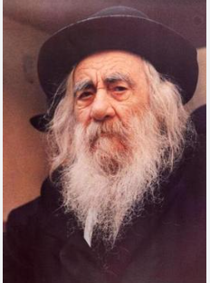

A boy suffering severe headaches was brought to the Steipler Gaon for chizuk by R’ Michel Silber. The Steipler asked him if he’s being matzliach, succeeding, in learning.
“No” was the response.
“That the source of the headaches,” said the Steipler. “The Sefer Chassidim teaches that whatever a person learns in This World, even though he may not understand it, in the Next World he nevertheless will understand with all its depth. Acknowledging this will give you chizuk and encouragement to persist, and ultimately prevent the headaches from returning.
“If you retain an appreciation for what you have and what you do, it will give you an inner satisfaction from learning, which will prevent the unwarranted headaches from returning, since there’ll be no need for the mind to be distracted from any emotional pain he won’t be encountering.” (Noam Hashem, p. 164)

Reprinted from the Parshat Bo 5784 email of Heartwarming Stories for the Shabbos Table.
Chazan Tzvi Hersh Tsatskis, a”h

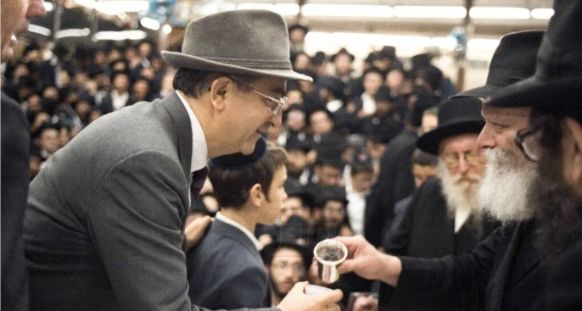
Chazan Tzvi Hersh Tsatskis getting a kos shel yayin (cup of wine) from the late Lubavitcher Rebbe, circa 1980s.

Chazan Tzvi Hersh Tsatskis, who learned music in the Soviet Union and went on to sing Jewish songs in America, and sang many times while the Rebbe distributed kos shel bracha, passed away on Shabbos, 10 Shvat, 5784/January 20th.
He was 85 years old.
Tzvi Hersh was born on Yom Kippur in 1938, in the city of Kazan, Tatarstan, then part of the Soviet Union. In his youth, he was educated in Torah by Chabad chassidim, who would come to his house in secret to teach him, despite the danger of imprisonment.
In this oppressive environment, his parents tried their best to be Torah observant. Even after the war, when the Tsatskis family moved to Moscow, where Jewish life was even harder, they took great pains to keep kosher, and against all odds they succeeded.

Tried to Avoid Desecrating Shabbos
In Moscow, young Tzvi Hersh attended public school and tried to avoid desecrating Shabbos as much as he could. He also “played hooky” on the Yomim Noraim. After that, in 1955, he went to university—the Moscow Conservatory of Music—to become a pianist, and was arrested twice while trying to attend the great Moscow Choral Synagogue. He was questioned and held in jail a few days each time, but he suffered no further fallout from those incidents.
From that time on, the Tsatkis family were actively trying to leave Russia. Finally, in 1970, a Chabad emissary went to the Lubavitcher Rebbe to ask for the Rebbe’s bracha that they get out. And less than a year later—at a time when this was near impossible!—they received the green light to go. As soon as the family arrived in America, they traveled to see the Rebbe to express our gratitude.

Saw Thousands of Jews Gathered Together
That was the first time Tzvi Hersh participated in a farbrengen and saw thousands of Jews gathered together—something which was forbidden in Russia. “It was amazing to hear the Rebbe speak and to see everyone so happy, singing with such joy. For me, it was an unbelievable experience,” he recalled in an interview with JEM’s my encounter.

“During the farbrengen I was sitting by the door as far away from the Rebbe as you could get, and I couldn’t hear him very well from there. But even if I could have heard him, I wouldn’t have understood much,” he said the Rebbe
Then, at the end of the farbrengen, the Rebbe began to distribute kos shel bracha, and Tzvi Hersh, seeing Ipeople lining up to receive it and say l’chaim, began debating with myself whether I should join them.

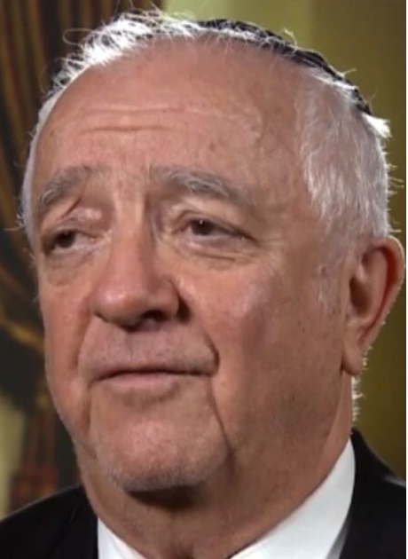
Chazon Tsatskis

“I wanted to, but not being a Chabad chassid, I wasn’t sure if I should, until I saw the line coming to an end. And then, on an impulse, I got up and stood at the back of the line. Before long I found myself in front of the Rebbe holding my cup,” he recalled.
The Rebbe gave him a big smile, poured wine into my cup, and he said l’chaim. He then started to walk away, but the Rebbe called him back.
“So, I came back, and he gave me an even bigger smile and poured a bit more wine into my cup. I said l’chaim again, and then he spoke to me in Russian: ‘Don’t have any more doubts.’ I was so shaken that I almost fainted. Then he said, ‘Sing!’ And I started to sing the Pesach song, ‘Who knows one?’ except I sang it in Russian: ‘Ech Ti Zemlyak . . .'” he related.
After that, he was privileged to sing many, many times at the Rebbe’s farbrengens.

Invited to Give a Concert to a Workmen’s Circle Group
At one point in time, Chazan Tsatkis was invited to give a concert of Jewish melodies in Manhattan for the Workmen’s Circle, a secular Jewish organization. During the
first intermission, somebody approached him and asked me to take off my yarmulke, and he refused.
And then, during the second intermission, another person came over to him. He said he was the vice president of the organization sponsoring the concert, and his organization was very happy that I was performing for them, but they were not comfortable with him wearing a yarmulke. “Would I please remove it?” the man asked.
Chazan Tsatskis got very upset, and told him, “You are the second person to come to me and ask me to take off my yarmulke. And if someone else comes, then I will not only not take it off, I will take out my tzitzit and make sure no one has any doubt that I am a Torah-observant Jew.” That put an end to that.
When he later came to see the Rebbe, he told him about this upsetting incident. As he was relating the story, he said, “I was giving a concert to a Jewish audience that was not observant . . .”

The Rebbe’s Response
At that, the Rebbe interrupted me: “Why do you say that they were not observant? They are observant; they just don’t know that they are observant!”
In the interview with JEM, he related one story with the Rebbe that stood out in his mind.
“Let me preface: I once brought my son to a farbrengen, but I did not bring my daughter. And right away the Rebbe asked, ‘Where is she? Where is Tanya?’
“When my son heard the Rebbe asking for Tanya, he ran to a make a call to my wife. She brought her right over—Tanya was then just a little girl—and when the Rebbe saw her, he waved to her. After that, I would bring her to Chabad events on many occasions.
“One time the Rebbe was distributing wine at the end of a festival, and many of the yeshivah students were singing chassidic songs. Standing on the stage not far from the Rebbe, I led a song, and Tanya, who was seven or eight years old at the time, began to sing along. When she did that, the Rebbe’s secretary indicated to me that she should stop, as the men present should not listen to the voice of a girl singing.
“The Rebbe noticed this and, concerned that she might be upset, put down his cup of wine, turned to her and motioned to her to clap. He was encouraging her to participate, and he did this for some time. I was amazed! That the Rebbe should consider the feelings of a child, and that he should take so much trouble to engage her!
“He had a tremendous love for every Jew and every person. In fact, what he felt was beyond love—it was a feeling of unity. He united us with him and with G-d.
I experienced this feeling, and I will never forget it,” Chazan Tsatskis remembered.
He is survived by his wife, Eda Tsatskis and children, Izzy Tsatskis and Tania Weissman.

Reprinted from the January 21, 2024 website of anash.org

Buried Treasure
By Aharon Spetner

“Look, Shimmy!” exclaimed Yitzy, as the two boys arrived at shul to learn after cheder. “It’s Farmer Richard!”
Shimmy looked up to see a giant red tractor making its way down the street towards the shul. Farmer Richard Bazoigenstein was a farmer who recently became a baal teshuvah, and often came to shul for Rabbi Friedman’s weekly halachah shiur.
“Hi Mr. Bazoigenstein,” said Yitzy, as the tractor pulled up.
“Is everything okay?” asked Shimmy, noticing that Farmer Richard’s face and clothes were covered in a black gloop. “It looks like someone dumped a barrel of dark chocolate pudding all over you!”

“I Came to Shul to Thank Hashem”
“Baruch Hu uvaruch shemo, everything is amazing!” answered Farmer Richard with a smile, climbing down from his tractor. “I came to shul to thank Hashem for the most incredible thing that happened to me. Would you like to hear the story?”
“Of course, we would!” both boys said, as they walked inside to where Totty was already sitting and learning.
“Well, I was driving my tractor back to the farm, when I passed an old farm that has been empty for as long as I can remember. And there was a sign outside saying it was for sale for a hundred dollars! Well, a hundred dollars is quite a bargain for a property that size, so I stopped my tractor and knocked on the door of the farmhouse.
“The lady who answered the door told me that the farm had been her father’s, but the soil was no good and there were rocks everywhere. They had tried to grow wheat for years and never managed to succeed. She said the farm was costing her a lot of money and she just wanted to get rid of it.”
“Wow,” said Shimmy. “So, what did you do?”
“Well, I figured even if the soil wasn’t good for growing wheat, I could grow plenty of carrots and potatoes there, so I gave her a hundred-dollar bill, bought the farm, took my shovel out into one of the fields, and started digging a small carrot patch.

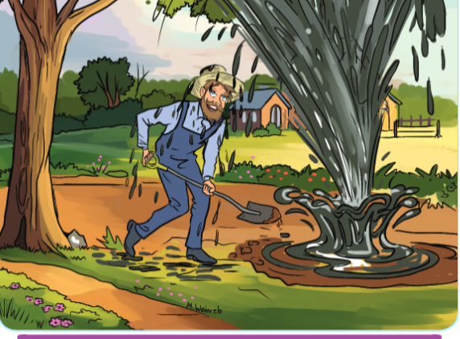
Illustrated by Miri Weinreb

“Now I’ve dug plenty of carrot patches before, but something just felt different here. Even though there were quite a few rocks, the soil felt somewhat spongy. It was weird. But I kept digging and soon the dry soil started getting all muddy.”
“Maybe there was a well under the ground,” suggested Yitzy.
“Oh, there was a well, all right, but not what you’re thinking. As I dug, I heard a rumbling sound. I stepped back in surprise just as a black fountain erupted out of the ground, shooting high into the sky!”
“You discovered oil!” Yitzy exclaimed.

“But a Deal was a Deal”
“Exactly,” replied Farmer Richard. “Now you can imagine, the lady who sold the farm to me started to wonder whether she should have sold the farm, but a deal was a deal. Within minutes news reporters showed up to ask me about it, and two hours later Anshel Holtzbacher came and bought the farm from me for ten million dollars! This is the second-most exciting day in my life!”
“Pshhhhh” whistled Shimmy, in awe.
“Let’s start digging in our backyard tonight!” Yitzy said excitedly. “Maybe we can find oil too!”
“Yeah - or buried treasure!” agreed Shimmy.
“Oil is buried treasure,” Yitzy said. “Didn’t you hear? Ten million dollars!”
“That is some story,” came Totty’s voice from behind them. “But you already have a treasure.”
“We do?” both boys said together.
“Well, let’s ask Mr. Bazoigenstein. You said this was the second-most exciting day in your life. What was the most exciting day?”
“Oh, that’s easy,” said Farmer Richard. “The most exciting day in my life was when I found out I was Jewish and Rabbi Freedman invited me for Shabbos.”
“Shabbos?” both boys asked.

Shabbos is the Most Special Thing Ever
“Oh yes, Shabbos is worth way more than even a billion dollars! It is the most special thing ever! And not just the cholent and the kugel. It’s a day just for us and the Ribon Baruch Hu - a special treat that we get because we are the children of Hakadosh Shel Olam!”
Totty smiled. “In this week’s Parsha [Beshalach] Hashem says – See that Hashem is giving you Shabbos’. Why did Hashem say - see’? It doesn’t say that by any other mitzvah. And that’s because Hashem is telling us that this is not stam a present - it is an extra-special present. We don’t want to be like the lady who sold Mr. Bazoigenstein the farm, without ever realizing what a great treasure was lying right there under her property. If we don’t appreciate how great Shabbos is, we are ignoring an incredible gift that we have had all along. Shabbos is an amazing treasure that we must value even more than millions of dollars, just like Mr. Bazoigenstein does.”
Have a Wonderful Shabbos!

Takeaway:
Hashem wants us to know what a great gift Shabbos is for us. It’s not enough to have a gift, we must know about it!

Reprinted from the Parshas Beshallach 5784 email of Toras Avigdor Junior, adapted from the Torah teaching of Rav Avigdor Miller, zt”l.

It Wasn’t Bashert in Canada
By Rabbi David Ashear

Yehoshua Rosenberg* had been in shidduchim for several years, yet nothing was working out. A shidduch was suggested in Canada and Yehoshua flew there to meet the young woman. After several dates, he told his parents he was ready to get engaged.
“I think it’s time for you to meet the Cohens* and finalize matters with them,” he suggested. The Rosenbergs hired a driver for the trip to Canada. The entire way there, Yehoshua and his parents were overflowing with happy anticipation. But they celebrated too soon. At the last minute, everything fell apart and the shidduch was abruptly called off.

Giving Chizuk to His Parents
The drive home, with the same driver, was not the same experience. The parents were unable to control their tears. Yehoshua, however, was giving his parents chizuk!
“It is all min haShamayim!” he declared. “Hashem is being so kind! She was the wrong girl. Hashem saved me from making the wrong decision. Don’t worry, I’ll find the person who was truly meant for me.”
By the end of the ride, the Rosenbergs had internalized their son’s words and were feeling much better. Yeshoshua became engaged a few weeks later – to the daughter of the man who drove them to Canada and back. He was so impressed by Yehoshua’s emunah that he wanted him for his own daughter! (Living Emunah)

Reprinted from the Parshas Beshallach 5784 email of The Weekly Vort.

The Imrei Yosef and the
Non-Religious Textile Owner
By Zev Greenwald

It was the night of Tu B’Shevat (circa 1850’s), and a large gathering of chassidim surrounded the table of the Imrei Yosef. At the head of the table sat the Rebbe, explaining the significance of Tu B’Shevat. He spoke of the things that men and trees have in common.
“With great effort and the investment of much energy, one can help a tree grow – even a crooked one that has lacked nourishment and water. Sometimes, through devoted and persistent care, we can turn a stunted tree into a blooming one.”
At that moment, a well-dressed Jew entered the room. He walked over to the table and set down a gigantic fruit basket. Looking up, the Rebbe showed this man exceptional warmth all through the evening.
None of the chassidim knew the stranger’s identity. Afterwards, they heard the story from the guest himself: “I was born in Germany and arrived here only a few years ago. My father was with the Haskalah (Enlightenment) movement in Germany, and raised me accordingly.
“On my arrival here, I opened a textile factory and became very successful. Once, I purchased an enormous quantity of raw material at an exceptionally low price. I paid for all the materials in cash and returned to my office. A while later, the supplier of the materials walked into my office and demanded payment for what he had sold me. I thought he was joking. It soon became clear that I had fallen into a trap.
“I remembered that the man had not signed a receipt for the money I had paid. What remained was the contract, signed by me, authorizing the materials to be transferred and obligating me to pay for them. Furious, I threw the man out of my office. He informed me that he planned to sue me in court. I felt frustrated and helpless. It was clear that he would win the case, leaving me impoverished.
“I went outside for a breath of fresh air. I ran into an acquaintance and told him about my misfortune. He suggested that I accompany him to see his Rebbe, the Imrei Yosef, and ask for advice. In my despair, I was ready to try anything. I’ll never forget the glow in the Rebbe’s eyes when I first saw him. I could not check the tears that coursed down my cheeks, and managed with difficulty to tell the Rebbe what had befallen me.
“The Rebbe asked if I kept Shabbos. I explained that a good deal of my business was done on Shabbos, making it impossible for me to refrain from working. The Rebbe then asked if I was careful to eat only kosher food. I answered in the negative. Then the Rebbe asked if I at least put on tefillin. Once again, my answer was no. The Rebbe guaranteed that if I put on tefillin each morning, I would win the case. I agreed to the Rebbe’s request and left him with a lighter heart.

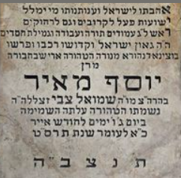
The matzeva (tombstone) of the Imrei Yosef, Rabbi Yosef Meir Weiss, zt”l

“From that day on, I faithfully put on tefillin every day. One mitzvah pulls another in its wake, and from the mitzvah of tefillin I began observing other mitzvos. My day in court arrived. It was Tu B’Shevat, exactly one year ago today. My chances of winning the case seemed nil, but I went to court in high spirits, placing my trust in the Rebbe’s promise.
“When I took the stand, I told the truth – that I had paid but had not received a receipt. The judge was persuaded of the truth of my story, and acquitted me of any wrongdoing. From that day on, my offices have been closed on Shabbos. Not only has this not harmed my interests, but business has boomed! I have begun to live a full life of Torah and mitzvos, though I am not an actual chassid.”
The man finished his tale and smiled. “Today, on the anniversary of the day when I won my court case because of the Rebbe – and when I was, so to speak, reborn – I thought it proper to bring the Rebbe a basket of the best fruits.” (Stories My Grandfather Told Me)

Reprinted from the Parshas Beshalach (the week in which Tu B’Shevat) 5784 email of The Weekly Vort.

